Market-based clustering
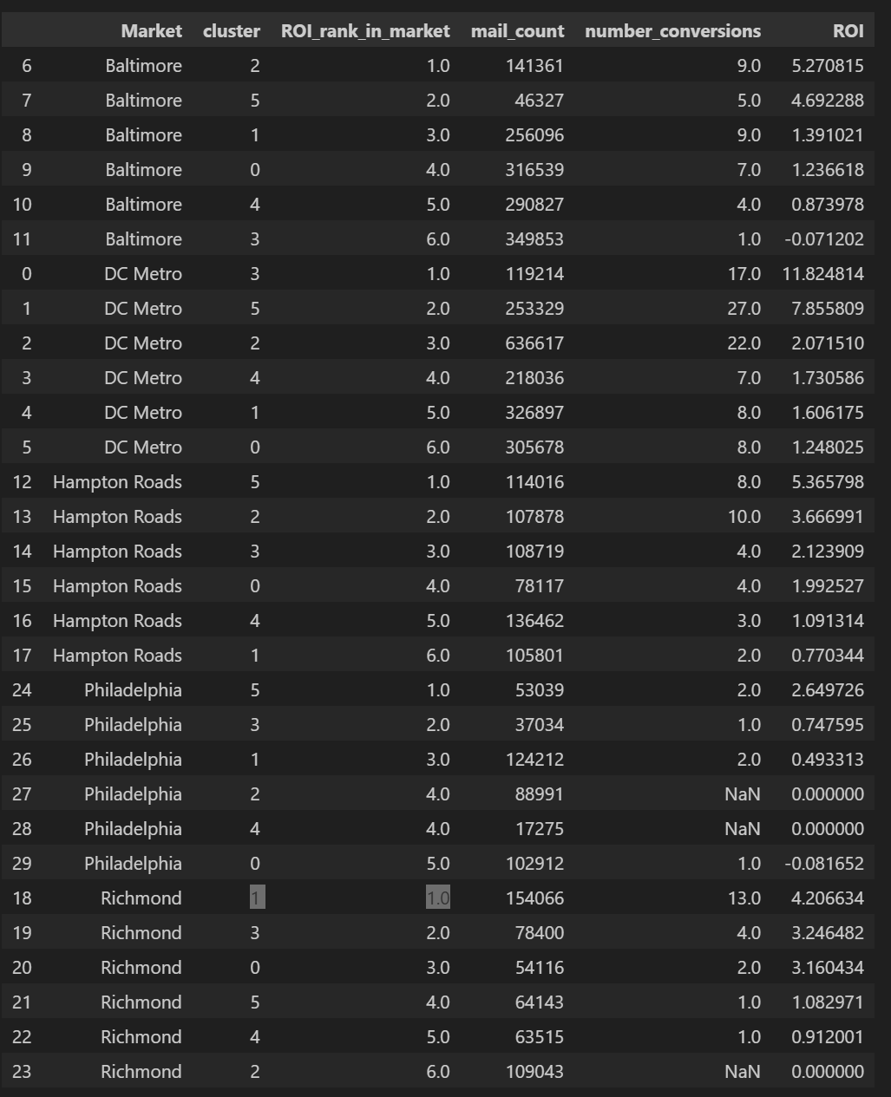

1. First, the most important observation
There is no single cluster that is “golden” across all markets.
Look at the Rank 1 clusters:
- Baltimore → cluster 2
- DC Metro → cluster 3
- Hampton Roads → cluster 5
- Philadelphia → cluster 5
- Richmond → cluster 1
That alone answers a major business question:
Markets behave differently. A single global clustering strategy will not maximize ROI everywhere.
This strongly justifies:
- market-specific models or
- market-specific targeting rules on top of clusters

2. ROI magnitude differs dramatically by market
Some examples:
- DC Metro
  - Top ROI ≈ 11.82
  - Second ≈ 7.86
- Baltimore
  - Top ROI ≈ 5.27
- Philadelphia
  - Top ROI ≈ 2.65
- Hampton Roads
  - Top ROI ≈ 5.36
This means:
- A “good” cluster in one market may be mediocre in another
- ROI thresholds should not be global

3. Volume vs ROI tradeoff is market-dependent
Let’s look at a few cases:

DC Metro
- Cluster 3:
  - ROI ≈ 11.8
  - Mail count ≈ 119k
  - Conversions = 17
→ High ROI, meaningful volume
This is a strong candidate for aggressive targeting.

Philadelphia
- Cluster 5:
  - ROI ≈ 2.65
  - Mail count ≈ 53k
  - Conversions = 2
→ ROI looks OK, but very sparse conversions
This is high uncertainty ROI, not something to blindly scale.

Baltimore
- Cluster 2:
  - ROI ≈ 5.27
  - Mail count ≈ 141k
  - Conversions = 9
→ Reasonable balance of ROI and volume

4. Some clusters are actively bad (important operational insight)
Examples:
- Baltimore cluster 3 → ROI ≈ -0.07
- Philadelphia cluster 0 → ROI ≈ -0.08
These clusters are:
- Consistently low ROI
- Sometimes negative
- Reasonable mail volume
This gives you clear “do not mail” candidates, market-specific.

5. What this means strategically
From this table alone, we can already say:
- Markets require independent optimization
- Cluster labels are not transferable across markets
- “Golden cluster” is a market-specific concept
- There is clear room for cost savings by suppressing bottom clusters
- Top ROI clusters differ not just by ID, but by risk profile

6. The real decision question now
At this point, the business question is no longer:
“Which cluster is best?”
It is now:
“For each market, how do we trade off ROI vs volume vs stability?”
This is where:
- tiering
- score cutoffs
- budget allocation
come in.

7. Stability Analysis of High-ROI Clusters
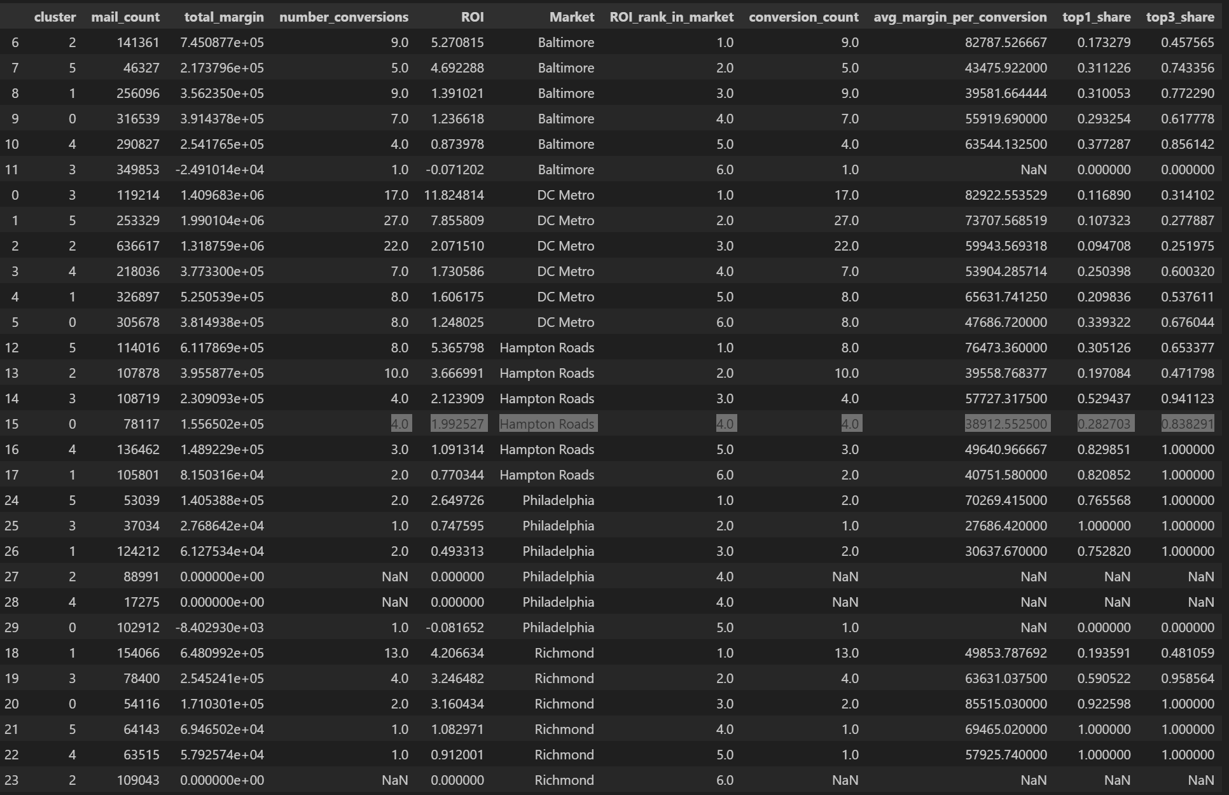

Objective
Evaluate whether high-ROI clusters deliver consistent, repeatable performance or whether their results are driven by a small number of outlier deals. This assessment helps distinguish scalable opportunities from fragile ones.

Stability Metrics Used
- top1_share
The proportion of a cluster’s total Gross Margin contributed by its single largest deal.
- top3_share
The proportion of a cluster’s total Gross Margin contributed by its three largest deals combined.
Lower values indicate more evenly distributed performance across conversions; higher values indicate reliance on a small number of deals.

Key Stability Findings

1. DC Metro — Strong and Robust Stability
The top-performing cluster in DC Metro shows:
- Low top1_share (≈ 0.12)
- Low top3_share (≈ 0.31)
- A relatively high number of conversions
This indicates that ROI is driven by multiple independent deals, not by outliers. Performance is robust and repeatable, making this cluster suitable for scaling.

2. Baltimore and Hampton Roads — Moderate Stability
Top clusters in these markets show:
- Moderate top1_share (≈ 0.17–0.31)
- Moderate top3_share (≈ 0.46–0.65)
- Several contributing conversions
ROI is partially concentrated but still supported by more than a single deal. These clusters are reasonably stable, though performance should be monitored as volume increases.

3. Philadelphia and Richmond — High Concentration Risk
High-ROI clusters in these markets show:
- top1_share close to or equal to 1.00
- top3_share close to or equal to 1.00
- Very few conversions
This indicates that reported ROI is driven by one or two large deals. Performance is fragile, highly sensitive to deal-level variance, and not reliable for aggressive scaling.

4. Low-ROI Clusters
Clusters with low or negative ROI typically show:
- Very low conversion counts
- Either no concentration signal (no deals) or extreme concentration
These clusters offer no stability advantage and remain candidates for suppression.

Stability-Based Interpretation
- High ROI alone is not sufficient to identify actionable clusters.
- Clusters combining high ROI and low concentration represent the most reliable opportunities.
- Clusters with high ROI but extreme concentration should be treated as speculative and handled conservatively.
- Stability varies significantly by market, reinforcing the need for market-specific strategies.

Conclusion
Stability analysis reveals that only a subset of high-ROI clusters exhibit repeatable, scalable performance. Incorporating concentration metrics alongside ROI is essential to avoid over-investing in clusters whose apparent profitability is driven by isolated outcomes rather than consistent behavior.

